

**ASSIGNMENT 2**

|  |  |  |
| --- | --- | --- |
|  |  |  |
| **COURSE** | **:** | WEB API DEVELOPMENT |
|  |  |
| **COURSE CODE** | **:** | CSC406 |
|  |  |  |
| **DURATION** | **:** | 2 HOURS |

## 

**CAPSTONE PROJECT PRELIMINARY STUDY**

**INSTRUCTIONS TO CANDIDATES:**

1. This assignment will allocates **15%** of carry marks.
2. This is an individual assignment.
3. Please demonstrate your work before submission.
4. Please upload the completed assignment into your github account.
5. Please submit your completed report in hardcopy.
6. Plagiarism, copying and cheating will not be tolerated, where no marks will be awarded and disciplinary actions can be taken.
7. The submission date is at WEEK 13 LATEST by **6th December 2019**.

**B: Report (10 marks)**

1. Explanation on step to request token from Youtube API.
2. CODE OF RELATED FILES

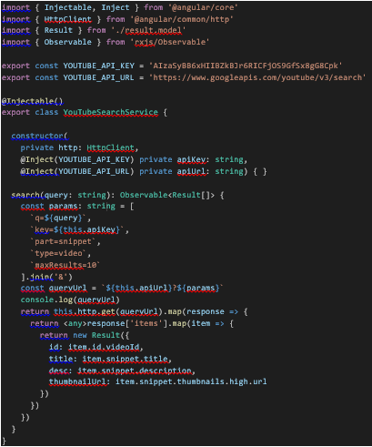

Code of Services to Put Api Key

<div class="col-sm-6 col-md-3">

  <div class="thumbnail">

    <img src="{{result.thumbnailUrl}}">

    <div class="caption">

    <h3>{{result.title}}</h3>

      <p>{{result.description}}</p>

    <p><a href="{{result.videoUrl}}" class="btn btn-default" role="button">Click to Watch</a></p>

    </div>

  </div>

</div>

Code of Search Result

<div align= "center" class='container'>

  <div class="page-header">

  <img src="https://cdn3.iconfinder.com/data/icons/social-icons-5/606/YouTube.png" height="150" width="150"><h1>

  <img style="float: right;" *ngIf="loading" src='assets/images/loading.gif' />

  </h1>

  </div>

  <div class="row">

  <div class="input-group input-group-lg col-md-12">

  <app-search-box (loading)="loading = $event" (results)="updateResults($event)"></app-search-box>

  </div>

  </div>

<br>

  <div class="row">

  <app-search-result *ngFor="let result of results" [result]="result"></app-search-result>

  </div>

</div>

Code of Search Component

export class Result {

  id: string

  title: string

  desc: string

  thumbnailUrl: string

  videoUrl: string

  constructor(obj?: any) {

    this.id           = obj && obj.id           || null

    this.title        = obj && obj.title        || null

    this.desc         = obj && obj.desc         || null

    this.thumbnailUrl = obj && obj.thumbnailUrl || null

    this.videoUrl     = obj && obj.videoUrl     || `https://www.youtube.com/watch?v=${this.id}`

  }

}

Code of Result

1. SCREENSHOT OF THE RESPONSE

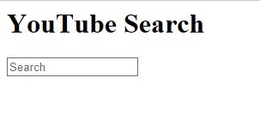

Youtube Interface

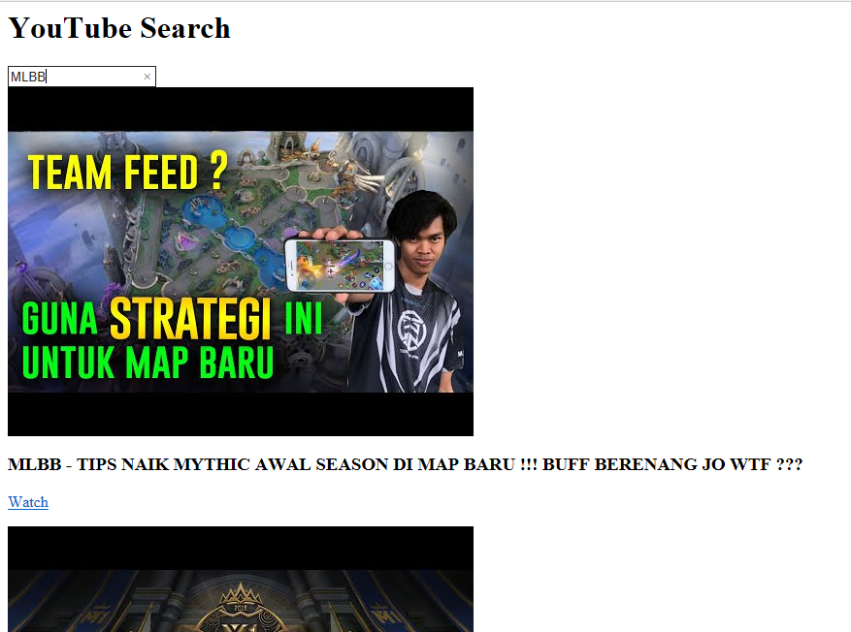

1. GIT PROJECT REPOSITORY ADDRESS

<https://github.com/iqbal966/YT-API>